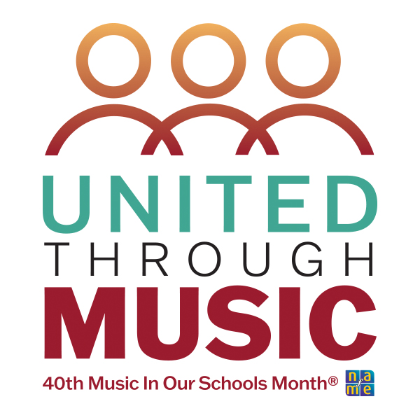
Listening
Music Lesson Plan

Title: When Louis Armstrong Taught Me Scat Grade Level: 4th

Source: Dr. Michelle McConkey

Materials needed:

Book: When Louis Armstrong Taught Me Scat by Muriel Harris Weinstein
Recording of Ella Fitzgerald, “You’ll Have to Swing It”
Recording of Louis Armstrong, “Heebie Jeebies”

Procedure:

Anticipatory Set: What are some different styles of music? (rap, country, jazz, classical) We all may like different types of music, but music brings people together. How?

- Today we’re going to listen to some jazz music. This song tells a story, but there’s a spot in here where the words don’t make sense. When you hear that part, shake your hands like this [sign language for clapping]. Listen to Ella Fitzgerald sing “You’ll Have to Swing It” and have students identify the scatting section.
- When a jazz singer sings these nonsense words, it’s called scat singing. The words don’t necessarily mean anything they just “give a song a flavor” (Wikipedia). Some also say scatting is used as a way for the voice to imitate an instrument. Music can be understood by everyone even if they don’t understand the language being sung. And scatting is a way to sing without a language.
- Listen to more and listen for the instrument imitation and other scat syllables.
- This recording is of Ella Fitzgerald, also known as the queen of scat. Louis Armstrong is another well-known jazz artist, and he is often given credit for inventing scat, though some say that’s not true. But the story goes that when he and his band were recording a song, “Heebie Jeebies,” in 1926, that his music fell to the ground. Not knowing the lyrics to the song, he invented a gibberish melody to fill time, expecting the cut to be thrown out of the recording, but that take of the song was the one released. And scat singing became popular. In fact, today many hip-hop music artists and rappers use scat singing to come up with the rhythms of their raps.
- Listen to an excerpt of Louis Armstrong Scat singing “Heebie Jeebies”.
- Today, we are going to experiment with creating our own scat singing. But first, I have a book that can help us. Read the book When Louis Armstrong Taught Me Scat (or watch a video version). Discuss how, in the story, the scatting and music brought the children together, because music unites people.
- As a class create their own 8-beat nonsense syllables (Ski ba bop ba dop bop, doo wop, bweep, wada, bling).
- Listen again to “You’ll Have to Swing It” and snap during the story part (slow), and then shake hands and sing their created scat during the scat part (fast). Discuss how as a class they were united through music.
- Extension: Using Orff instruments, learn to improvise over a 12-bar blues form. As a class, create their own scat song around a topic, using the book as an example. Put together for a class composition.

Closure:
- What are the nonsense words in jazz singing called? (Scat)
- Who is a well-known scat singer? (Louis Armstrong or Ella Fitzgerald)
- How does music unite people?

Educational Objective: By the end of this lesson, students will have learned . . .
What Scat singing is, how it unites people, and to identify two Jazz artists (Louis Armstrong & Ella Fitzgerald) known for Scat singing.

Music Standards Utilized:

CREATING | Anchor Standard 1:  Generate and Conceptualize Artistic Ideas and Work | Process Component:  MU:Cr1.1.4a Improvise rhythmic, melodic, and harmonic ideas, & explain connections…  MU:Cr1.1.4b Generate musical ideas…within related tonalities…& meters.  MU:Cr2.1.4a Demonstrate… musical ideas for an improvisation, arrangement, or composition…  MU:Cr3.1.4a Evaluate & refine…revisions to personal music….  MU:Cr3.2.4a Present the final version of personal created music….
PERFORMING | Anchor Standard | Process Component:
RESPONDING | Anchor Standard | Process Component:  MU:Re7.1.4a Demonstrate & explain how selected music connects to and is influenced by specific interests, experiences, purposes, or contexts.
CONNECTION | Anchor Standard | Process Component:  MU:Cn10.0.4a Demonstrate how interests, knowledge, and skills relate to personal choices & intent when creating, performing, and responding to music.

Social Emotional Learning  (SEL standards) | SEL 4 Refinement of artistic work is an iterative process that takes time, discipline, self-confidence, and collaboration  SEL 10 Engagement in the arts provides opportunity to develop mutual respect for differing viewpoints (personal, cultural, societal and historical).
Cognitive Learning | SEL 17 Artists rely upon problem solving, critical thinking, and personal perspective when making creative choices.
Physical Learning | Playing instruments and responding to music by shaking hands and snapping.
Non-Musical Subjects | ELA (Reading): Refer to details and examples in a text when explaining what the text says explicitly and when drawing inferences from the text.
Universal Design for Learning (UDL) | Consideration 5.2 Use multiple tools for construction, composition, and creativity  Consideration 7.3 Nurture Joy & Play  Consideration 8.3 Foster collaboration, interdependence, and collective learning

