Sample News Announcement:
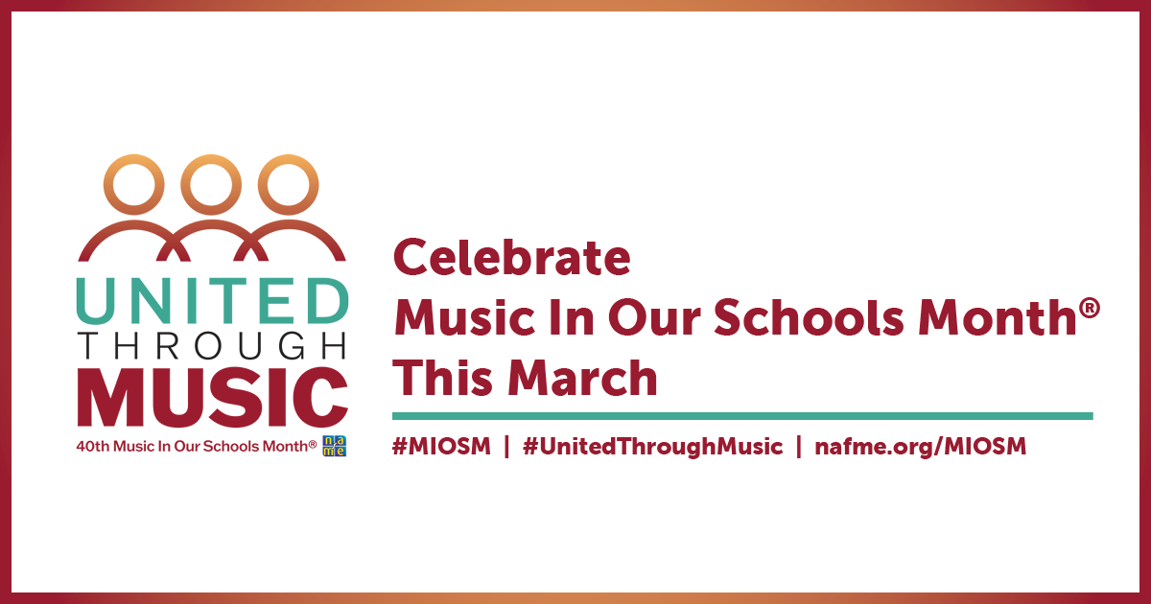

March Marks the
40th Anniversary of Music In Our Schools Month®!

[Date – City, State]—For 40 years, March has been designated by the National Association for Music Education (NAfME) as Music In Our Schools Month® (MIOSM®). The positive impact of music education in the lives of students lasts a lifetime. Therefore, ensuring equitable access to music education for the youngest members of our society—students—is paramount.

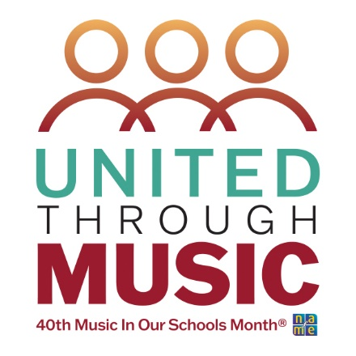
Every day, in classrooms and rehearsal rooms across our school district, music educators dedicate themselves to reaching all students with life-changing musical experiences. Parents, administrators, and the wider community often only see the wonderful results of music performances; however, we miss the months of practice and rehearsals and more importantly the learning process that takes place to make it all happen.

I encourage members in our community to acknowledge and celebrate music education as an essential part of every student’s educational journey.

[Insert your stories/testimonials from your school and district]

